**2497147**

**Mthokozisi Kubheka**

**IxD Process**

Goal Alignment

* The goal is to create an easy-to-navigate website containing pieces of my portfolio and technical documentation. This will be done through the usage of HTML and CSS.
* The user in this case will be the marker of the website and maybe some of my peers. Their main goal in visiting the website is to get pieces of the portfolio as previously mentioned.

Information Structure

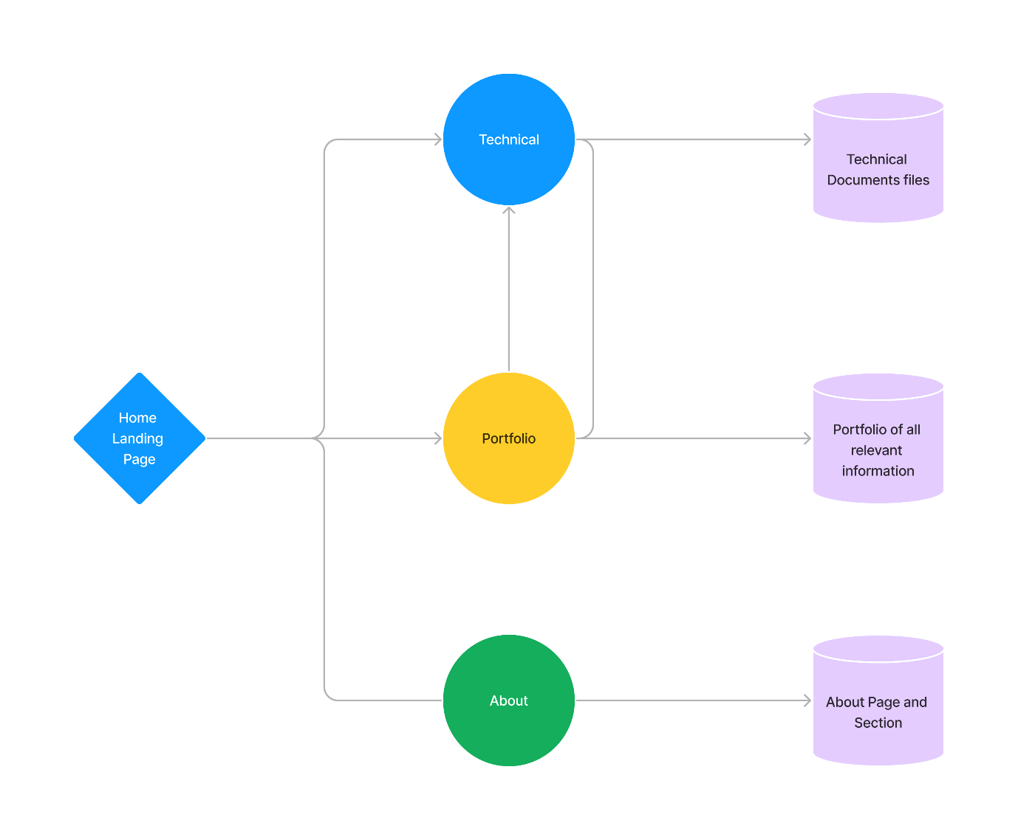

User Flow

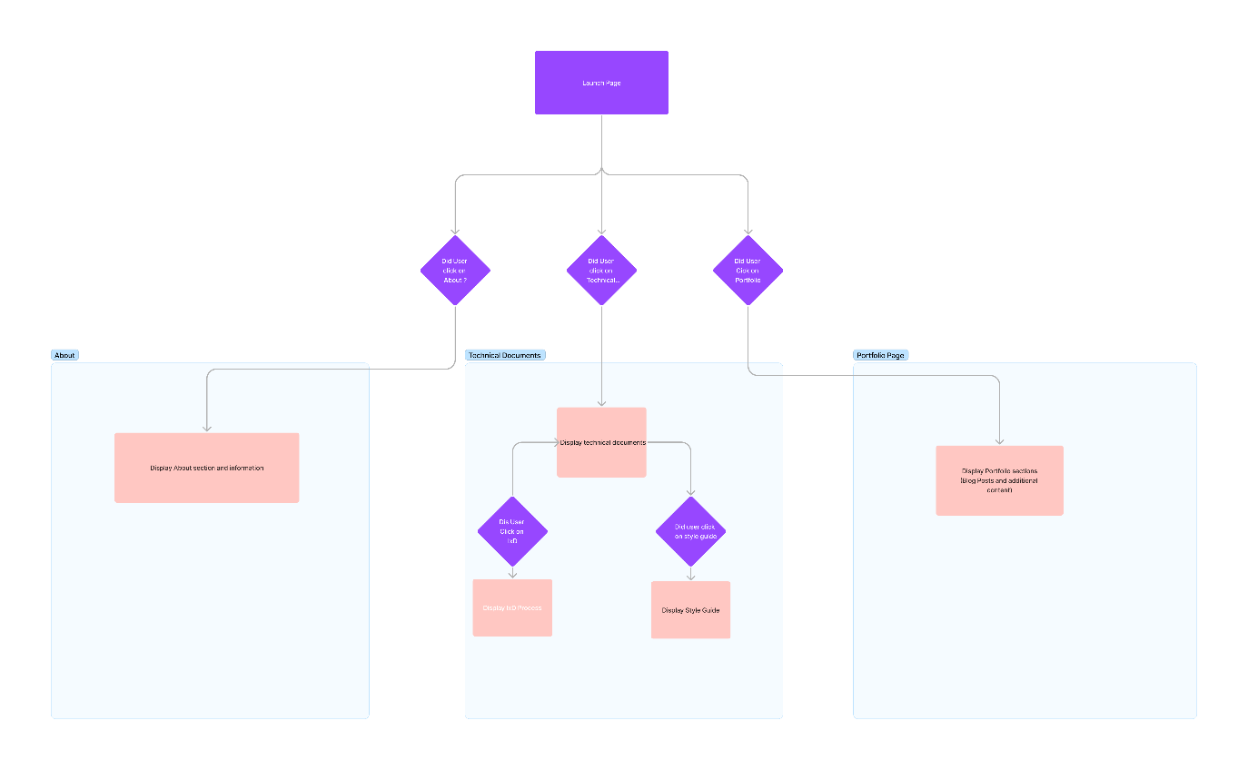

Interface elements

Input Controls :

* Buttons: With links to the different pages

Navigation

* Breadcrumb - Allowing the user to view the page they’re on, and navigate easily to the previous page.

**Style Process**

My goal is to create a simple and easy-to-navigate site, with some inspiration from a variety of sites.

**Style Guide**

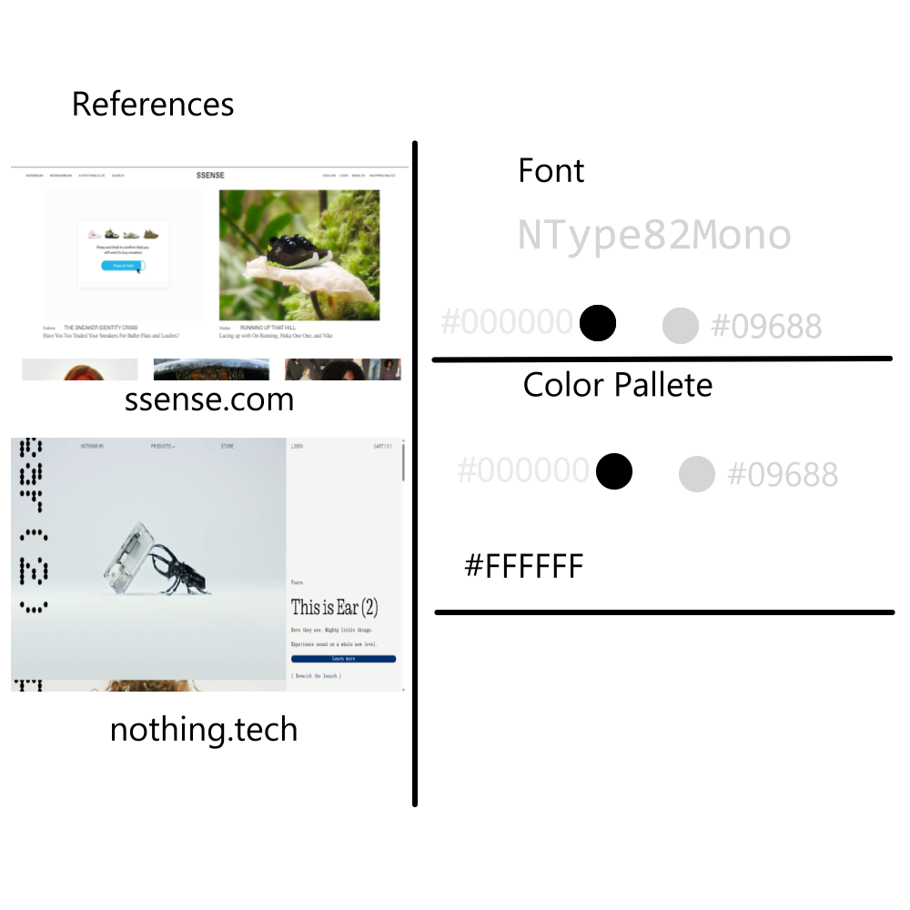

**Visual Aesthetic**

* Using the common black-white and grey style
* Line: Mostly static use of line, apart from menu selection
* Color : mostly neutral
* Shape :Rectangles and squares to keep a consistent look